**Complex Line integral**

Let be continuous at all points of a curve [fig] which we shall assume has finite length, i.e. is a rectifiable curve.

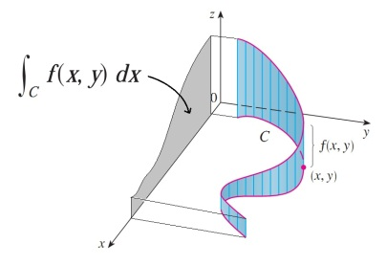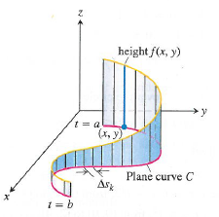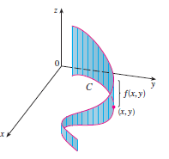Subdivide into parts by means of points , chosen arbitrarily, and call . On each arc joining to [where goes from to ] choose a point .

Form the sum

On writing this becomes

Let the number of subdivisions increase in such a way that the largest of the chord lengths approaches zero. Then the sum approaches a limit which does not depend on the mode of subdivision and we denote this limit by

(1)

Called the complex line integral or briefly line integral of along curve , or the definite integral of from to along curve .

**Real Line Integrals**

If and are real functions of and continuous at all points of curve , the real line integral of along curve C can be defined as

**Relation between Real and complex line Integrals**

If , the complex line integral (1) can be expressed in terms of real line integral as

(2)

For this reason (2) is sometimes taken as a definition of a complex line integral.

N.B. Properties and formulas of Real line integral are applicable.

**Simply and multiply connected regions:** A region Ris called simply connected if any simple closed curve which lies in R can be shrunk to a point without leaving R. A region R which is not simply-connected is called multiply-connected.

**Jordan curve:** Any continuous, closed curve which does not intersect itself and which may or may not have a finite length is called a Jordan curve.

**Green’s theorem in the plane:**Let  and  be continuous and have continuous partial derivatives in a region R and on its boundary C. Green’s theorem states that



The theorem is valid for both simply- and multiply-connected regions.

**Complex form of Green’s theorem:** Let  be continuous and have continuous partial derivatives in a region R and on its boundary C, where  are complex conjugate coordinates. Then Green’s theorem can be written in the complex form



where  represents the element of area .

**Cauchy’s theorem or The Cauchy-Goursat theorem:** If be analytic in a region R and on its boundary C. Then

.

This theorem is valid for both simply- and multiply- connected regions.

**Morera’s theorem:** Let be continuous in a simply-connected region R and suppose that



around every simple closed curve C in R . Then is analytic in R.

This theorem is called converse of Cauchy’s theorem.

**Theorem-**01**:**Prove the Cauchy’s theorem if  is analytic with derivative  which is continuous at all points inside and on a simple closed curve C.

**Proof:** Since  is analytic and has a continuous derivative



it follows that the partial derivatives

 (1)

 (2)

are continuous inside and on C.

thus Green’s theorem can be applied and we have







. **(Proved)**

**Theorem-**02**:**Prove the Cauchy-Goursat theorem for the case of a triangle.

**Proof:** Consider any triangle in the z-plane such as ABC, denoted briefly by , in Fig.1. Join the midpoints D, E and F of sides AC, AB and BC respectively to form four triangles indicated briefly by , ,  and .

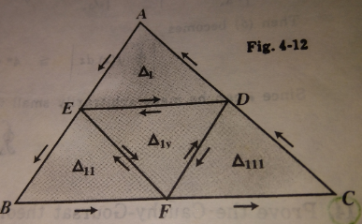

Fig.1

If  is analytic inside and on triangle ABC we have,





 ; 



Then (1)

Let be the triangle corresponding to that term on the right of (1) having largest value (if there are two or more such terms then  is any of the associated triangles). Then

 (2)

By joining midpoints of the sides of triangle , we obtain similarly a triangle  such that

 (3)

So that (4)

After n steps we obtain a triangle  such that

 (5)

Now ,,, … … ,  is a sequence of triangles each of which is contained in the preceding and there exists a point  which lies in every triangle of the sequence.

Since  lies inside or on the boundary of , it follows that  is analytic at .

Then  (6)

where for any , we can find  such that  whenever .

Thus by integration of both sides of (6), we get

 (7)

Now if P is the perimeter of , then the perimeter of  is . If z is any point on , then we must have .

Hence from (7), we have



Then (5) becomes



Since  can be made arbitrarily small it follows that, as required,

**(Proved)**

**Theorem-03:**Prove Morera’s theorem under the assumption that  has a continuous derivative in R.

**Proof:** If  has a continuous derivative in R, then by applying Green’s theorem in the connection between real and complex line integrals, we have





Then if around every closed path C in R, we must have



around every closed path C in R.



Hence the Cauchy Riemann equations are satisfied and thus is analytic. (**Proved**)

**Theorem-04:**Prove Green’s theorem in the plane if C is a simple closed curve which has the property that any straight line parallel to the coordinate axes cuts C in at most two points.

**Proof:** Let  and  be continuous and have continuous derivatives in a region R and on its boundary C.

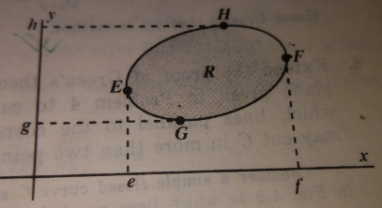

Let the equations of the curves EGF and EHF are  and respectively. Then











 (1)

Similarly, let the equations of the curves GEH and GFH are  and respectively. Then









 (2)

Adding (1) and (2), we get

**(Proved)**

**Problems**

**Problem-01.**Evaluate along

(a) the parabola .

(b) the straight lines from (0, 3) to (2, 3) and then from (2, 3) to (2, 4);

(c) a straight line from (0, 3) to (2, 4).

**Solution: (a)** From the parabola at the points (0, 3) and (2, 4)

we getandrespectively.

Also we have,

Then the given integral is,

**(b)** Along the straight line from (0,3) to (2,3) , we have

.

The line integral is,

Again, along the straight line from (2,3) to (2,4), we have

.

The line integral is,

Then the required value is = 44/3+5/3=103/6.

**(c)** The equation of the straight line from (0,3) to (2,4) is,

.

Solving for *x*, we have.

The line integral is,

**Problem-02:**Evaluate along

(a) the curve

(b) the straight line from (0, 1) to (0, 5) and then from (0,5) to (2,5).

**Solution:**Given that

1. Along the curve , the integral is,







s

.

1. Along the straight line from (0, 1) to (0, 5), and the line integral equals,



Along the straight line from (0, 5) to (2, 5), and the integral equals



Then the required value .**(Ans)**

**Problem-03:** Verify Green’s theorem in the plane for  where C is the closed curve of the region bounded by  and .

**Solution:** The plane curves  and  intersect at  and . The positive direction in traversing C is as shown in the following Figure.

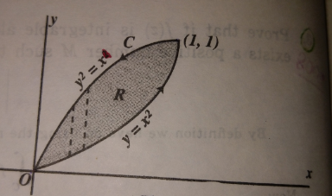

Along , the line integral is,







Along , the line integral is,





.

Then the required integral .

Again, here  and 













.

Hence Green’s theorem is verified.

**Problem-04:** Verify Green’s theorem in the plane for  where C is a square with vertices at , , and .

**Solution:** Given that 

and the vertices of the square C are , , and .

The square constructed by the given vertices is,









Along the straight line from to , and the integral equals,



Along the straight line from to , and the integral equals,



Along the straight line from to , and the integral equals,



Along the straight line from to , and the integral equals,



Then the required value is .

Again, here  and .

Now 













Hence the Green’s theorem is verified.

**Problem-05:** Evaluate  around a triangle in the xy plane with vertices at , and .

**Solution:** Given that 

and the vertices of the triangle C are , and .

The triangle constructed by the given vertices is,







Along the straight line from to , and the integral equals,



Along the straight line from to , and the integral equals,



Along the straight line from to , and the integral equals,



Then the required value is .

**Problem-06:** Prove (a) , (b) , (c) where C is any simple closed curve and  is a constant.

**Solution:** From the definition of complex line integral we have,

 (1)

1. Here . Since is arbitrary and hence putting  and  successively in

(1) we get

 (2)

and  (3)

adding (2) and (3) we get













if  and  where  and  are the starting and ending points of C.

If C is a close curve then .

**(Proved)**

1. Here .

Putting this in (1) we get

 (2)









if  and  are the starting and ending points of C.

If C is a close curve then .

**(Proved)**

1. Here .Since is arbitrary and hence putting  and  successively

in(1) we get

 (2)

and  (3)

adding (2) and (3) we get













if  and  where  and  are the starting and ending points of C.

If C is a close curve then .

**(Proved)**

**Problem-07:**Show that is independent of the path joining points  and . Also evaluate the integral.

**Solution:**Given that

Here  and 

 and 

Since  so the integral is independent of the path. **(Showed)**

**2nd part:**  The straight line from to  is,



Along this line the integral equals,



















**(Ans)**

**Problem-08:**Show that from  to along the curve C given by

(a). 

(b). the line from  to  and then the line from  to .

**Solution:** Given that



1. The line from  to is the same as the parametric equations  from  to . Then the line integral equals,







.

1. The line from  to is the same as the line from to for which ,

and the line integral equals,



Again, the line from  to is the same as the line from to for which , and the line integral equals,



Then the required value . **(Ans)**

**Problem-09:**Evaluate along (a) the parabolafromto ,

(b). the straight lines from to  and then from to 

**Solution:** Given that



1. Along the parabola from  to , the line integral equals,







.

1. The line from  to is,and the line integral equals,



Again, The line from  to is , and the line integral equals,



Then the required value . **(Ans)**

**Problem-10:**Evaluate  around the ellipse C defined by, if C is described in a counterclockwise direction.

**Solution:** Given that

Along the ellipse defined , , , the line integral equals,











.

**Problem-11:**Evaluate around the square with vertices atto , and 

**Solution:** Given that



and the vertices of the square C are , , and .

The square constructed by the given vertices is,









Along the straight line from to , , the line integral equals,



Along the straight line from to , the line integral equals,



Along the straight line from to , , the line integral equals,



Along the straight line from to , and the integral equals,



Then the required value is .**(Ans)**

**Problem-12:**Let be analytic in a region R bounded by two simple closed curves and  and also on and . Prove that , where and  are both traversed in the positive sense relative to their interiors.

**Solution:**

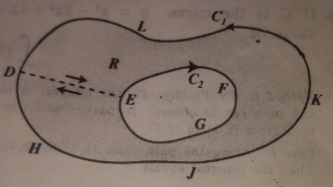

Construct cross- cut DE. Then since is analytic in the region R, we have by Cauchy’s theorem





Hence since 

. **(Proved)**

**Problem-13:**Evaluate , where C is any simple closed curve and  is (a) outside C,

1. inside C.

**Solution: (a)** If  is outside C, then  is analytic everywhere inside and on C.

Hence by Cauchy’s theorem,

.

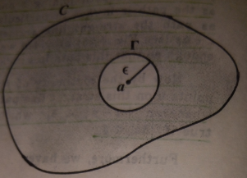

**(b)** If  is inside C and let  be a circle of radius  with centre at  so that is inside C.

Then

 (1)

Now on ,









From (1), we get



which is the required value.

**Problem-14:**Evaluate , where  is inside the simple closed curve C.

**Solution:** Since is inside C so let be a circle of radius  with centre at  so that  is inside C.

Then

 (1)

Now on ,









From (1), we get



which is the required value.

**Problem-15:**Evaluate  around (a) the circle , (b) the square with vertices at , .

**Solution:** Given that 

1. Since  is inside the circle . So,







Now, 

which is the required value.**(Ans)**

1. Since  is inside the square so let ,  be the circle of radius 2 which lies inside the

circle. Then

 (1)

Now on ,







Now, 

which is the required value.**(Ans)**

**Problem-16:** Verify Green’s theorem in the plane for  where C is the boundary of the region enclosed by the circles , .

**Solution:** Given that, 

The given circles are  and .

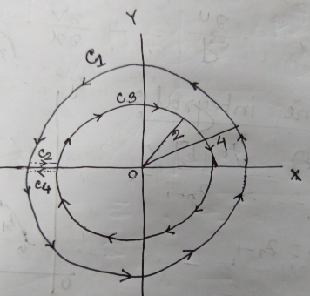

Along the region constructed by the given circles, the line integral reduces as



Along , the line integral is,

















Along , the line integral is,

















Here  has been measured in anticlockwise but in the constructed figure it is in clockwise. So if we measure it in clockwise then we will get



Now from (2) we get





Again, here  and 







 ; where 









.

Hence Green’s theorem is verified.

**[NOTE: By curvilinear coordinate  for details see the chapter-01 Hydrodynamics].**

**Problem-17:**Evaluate  along (a) the circle  from to in a counterclockwise direction, (b) the straight line from to , (c) the straight lines from to and then from to .

**Ans:**for all cases

**Problem-18:**Evaluate  along the arc of the cycloid ,from the point where  to the point where .

**Problem-19:**Evaluate  along the straight line joining  and .

**Solution:** Given that



The line from  to is the same as the line from to  which is,and the line integral equals,











**(Ans)**

**Problem-20:** Using Green’s theoremevaluate  around a triangle in the xy plane with vertices at , and with positive orientation.

**Solution:** Given that 

where and

and the vertices of the triangle C are , and .

The triangle constructed by the given vertices is,









The following inequalities define the region enclosed.

.

By Green’s theorem,



we get













** (Ans)**

**ONLINE LINK:**[**http://tutorial.math.lamar.edu/Classes/CalcIII/GreensTheorem.aspx**](http://tutorial.math.lamar.edu/Classes/CalcIII/GreensTheorem.aspx)

**Problem-21:** Prove that if  is integrable along a curve C having finite length L and if there exists a positive number M such that on C, then .

**Problem-22:**Show that Green’s theorem in the plane is valid for a multiply-connected region R such as shaded in Fig. 4-10 page-101 schaum series

**Problem-23:**Prove the Cauchy-Goursat theorem for any closed polygon. Page 104

**Problem-24:**If is analytic in a simply-connected region R, prove that  is independent of the path in R joining any two points a and b in R. page-106

**Problem-25:**Find the value of the integral , where C is the right-hand half of the circle . Page-244 shahidullah

**Problem-26:** Evaluate  around the circle  where s is the arc length.

**Problem-27:** Evaluate  around the circles (a), (b) .

**Problem-28:** Evaluate  around (a) the circle, (b) the square with vertices at and , (c) the ellipse .

**Problem-29:**Prove that  around any simple closed curve C.